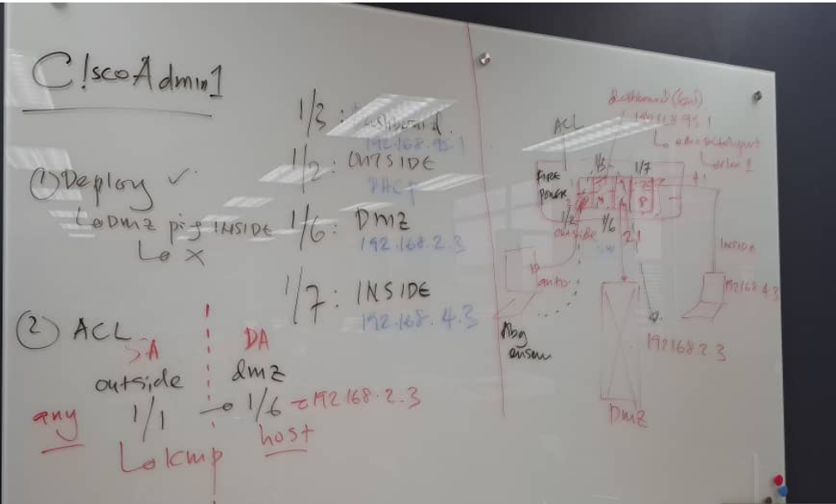

Configuring Cisco Firepower Threat Defense (FTD) involves several steps, from initial setup to deploying and managing policies. Here’s a general guide to configuring Firepower using Firepower Management Center (FMC), which provides centralized management for Firepower devices.
Step 1: Initial Setup of Firepower Device
- Connect to the Device:
  - Use a console cable to connect to the device.
  - Power on the Firepower appliance and access it via a terminal client (e.g., PuTTY or SecureCRT).
- Access the CLI:
  - Log in using the default credentials (admin/Admin123)
  - username: admin /password: C!5c0!23
  - Run the setup wizard if it's the first time booting the device:
shell
Copy code
sudo configure manager local <FMC_IP>
  - Set IP addresses, hostname, domain, gateway, and DNS for the device.

- Assign the Manager (FMC):
  - Register the Firepower device to the Firepower Management Center (FMC) if you're using one for centralized management:
shell
Copy code
configure manager add <FMC_IP> <Registration_Key>
  - The registration key must match the one configured on the FMC.
Step 2: FMC Setup and Device Registration
- Access the FMC Web Interface:
  - Open a web browser and navigate to https://<FMC_IP>.
  - Connect LAN cable to eth which is configure as switch: https://192.168.95.1
  - Log in using your admin credentials.

- Add the Firepower Device:
  - Go to Devices > Device Management.
  - Click Add > Add Device.
  - Enter the device IP address, registration key (set during the initial device setup), and other details.
  - Click deploy
  - Assign a group and policy to the device (optional).

- Licensing the Device:
  - Go to System > Licenses > Smart Licenses.
  - Register the Firepower appliance to a Cisco Smart Account if needed.
  - Assign the appropriate licenses to the device (e.g., Threat, Malware, URL Filtering, etc.).
Step 3: Network Configuration
- Configure Interfaces:
  - Go to Devices > Device Management and click on your Firepower device.
  - Click the Interfaces tab.
  - Configure IP addressing, VLANs, and security zones for each interface.
  - Assign each interface to the correct network zone (inside, outside, DMZ, etc.).
- Configure Routing:
  - Go to Devices > Device Management > Routing.
  - Add static routes, dynamic routing protocols (OSPF, BGP), and any necessary NAT rules.
Step 4: Create Access Control Policies
- Access Control Policies:
  - Go to Policies > Access Control.
  - Create a new access control policy.
  - Define rules that control traffic based on source/destination IPs, ports, applications, URLs, etc.
  - Enable Intrusion Prevention or Malware Detection if required.
- Apply the Policy:
  - After creating the access control policy, apply it to the device by going to Devices > Device Management and selecting your Firepower device.
  - In the Policy Assignments tab, assign the access control policy to the device.
Step 5: Enable Intrusion Policies (IPS)
- Intrusion Prevention System (IPS):
  - Go to Policies > Intrusion > Intrusion Policy.
  - Create or modify an existing intrusion policy.
  - Enable rules based on severity, policy recommendations, or custom configurations.
  - Apply this policy within your access control policy to activate it for specific traffic flows.
Step 6: Configure NAT Policies
- Network Address Translation (NAT):
  - Go to Policies > NAT.
  - Create a new NAT policy.
  - Define the source, destination, and translated addresses for different network flows (e.g., inside-to-outside traffic).
  - Apply the NAT policy to the relevant interfaces.
Step 7: Logging and Monitoring
- Set Up Logging:
  - Go to Policies > Access Control and enable logging for relevant rules in the access control policy.
  - Define log levels (e.g., connections, denied traffic) and storage preferences (e.g., local, external syslog).
- Monitor the Device:
  - Use the Analysis tab in FMC to view detailed dashboards on traffic, threats, and policy hits.
  - Set up alerts for various network and security events.
Step 8: Deploy Changes
- After configuring policies, interfaces, and settings, go to the Deploy section in FMC.
- Select the Firepower device and click Deploy to push the configuration to the device.
Additional Considerations:
- High Availability (Optional): Configure HA if you have two Firepower devices. Go to Devices > Device Management, select the device pair, and configure the HA settings.
- VPN Configuration (Optional): Configure site-to-site or remote access VPNs under Devices > VPN > Add VPN.

